Name – S.M.DINESH

Registration No. – RA2011028010057

Department – CSE W/S in Cloud Computing

Aim : Install and learn using AWS CLI

# 1] AWS Help

The built-in AWS CLI help command. You can get help with any command when using the AWS Command Line Interface (AWS CLI). To do so, simply type help at the end of a command name. For example, the following command displays help for the general AWS CLI options and the available top-level commands.

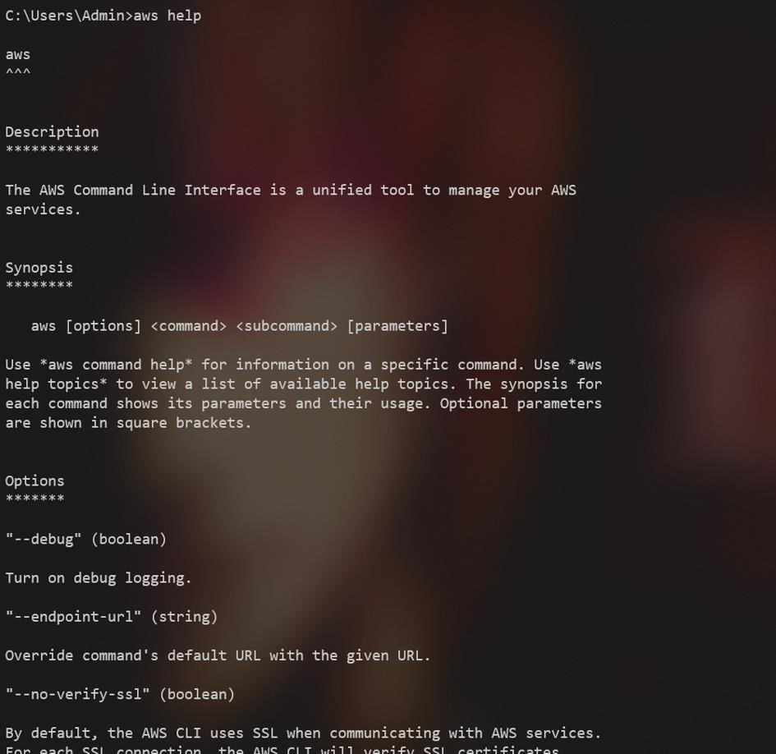

# 2] AWS – version

The AWS CLI version 2 is the most recent major version of the AWS CLI and supports all of the latest features

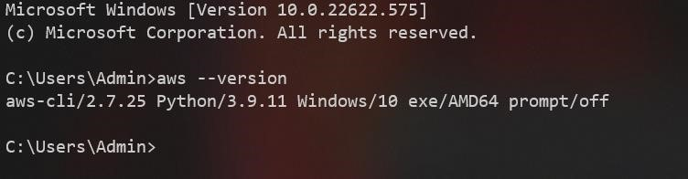

# 3] AWS configure

AWS Config is a service that enables you to assess, audit, and evaluate the configurations of your AWS resources. Config continuously monitors and records your AWS resource configurations and allows you to automate the evaluation of recorded configurations against desired configurations.

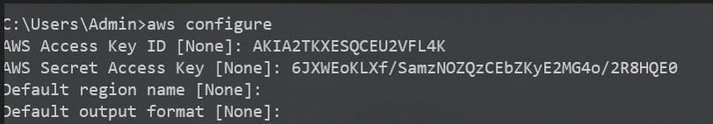

# 4] sts get-caller-identity

To get your account id using AWS CLI, run the sts get-caller-identity command, setting the --query parameter to Account to filter the output. Copied! The get-caller-identity command returns the User Id, Account Id, and the ARN of the caller

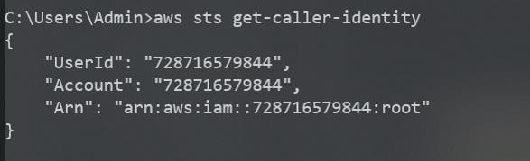

# 5] aws s3 ls

To list your buckets, folders, or objects, use the s3 ls command. Using the command without a target or options lists all buckets.

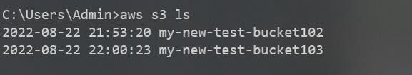

# 6] aws s3 ls bucketName

The following ls command lists objects and common prefixes under a specified bucket and prefix. In this example, the user owns the bucket mybucket with the objects test.txt and somePrefix/test.txt. The LastWriteTime and Length are arbitrary. Note that since the ls command has no interaction with the local filesystem, the s3:// URI scheme is not required to resolve ambiguity and may be omitted



# 7] create bucket

To create a bucket, you must register with Amazon S3 and have a valid Amazon Web Services Access Key ID to authenticate requests. Anonymous requests are never allowed to create buckets. By creating the bucket, you become the bucket owner. Not every string is an acceptable bucket name.

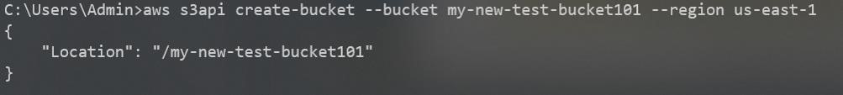

# 8] copy bucket

To download an entire bucket to your local file system, use the AWS CLI sync command, passing it the s3 bucket as a source and a directory on your file system as a destination, e.g. aws s3 sync s3://YOUR_BUCKET . .



# 9] delete bucket

If your bucket does not have versioning enabled, you can use the rb (remove bucket) AWS CLI command with the --force parameter to delete the bucket and all the objects in it. This command deletes all objects first and then deletes the bucket.

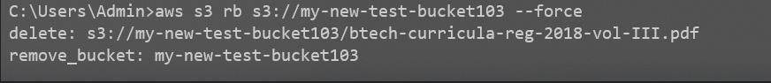

# 10] remove file from bucket

To delete objects in a bucket or your local directory, use the s3 rm command. For a few common options to use with this command, and examples, see Frequently used options for s3 commands. For a complete list of options, see s3 rm in the AWS CLI Command Reference. The following example deletes filename

